Business Plan:
Powering the Mobile Enterprise
Srllllll
Asante Ditau Chem (Pty) Ltd
“Your Partner in Clean, Your Advantage in Supply”

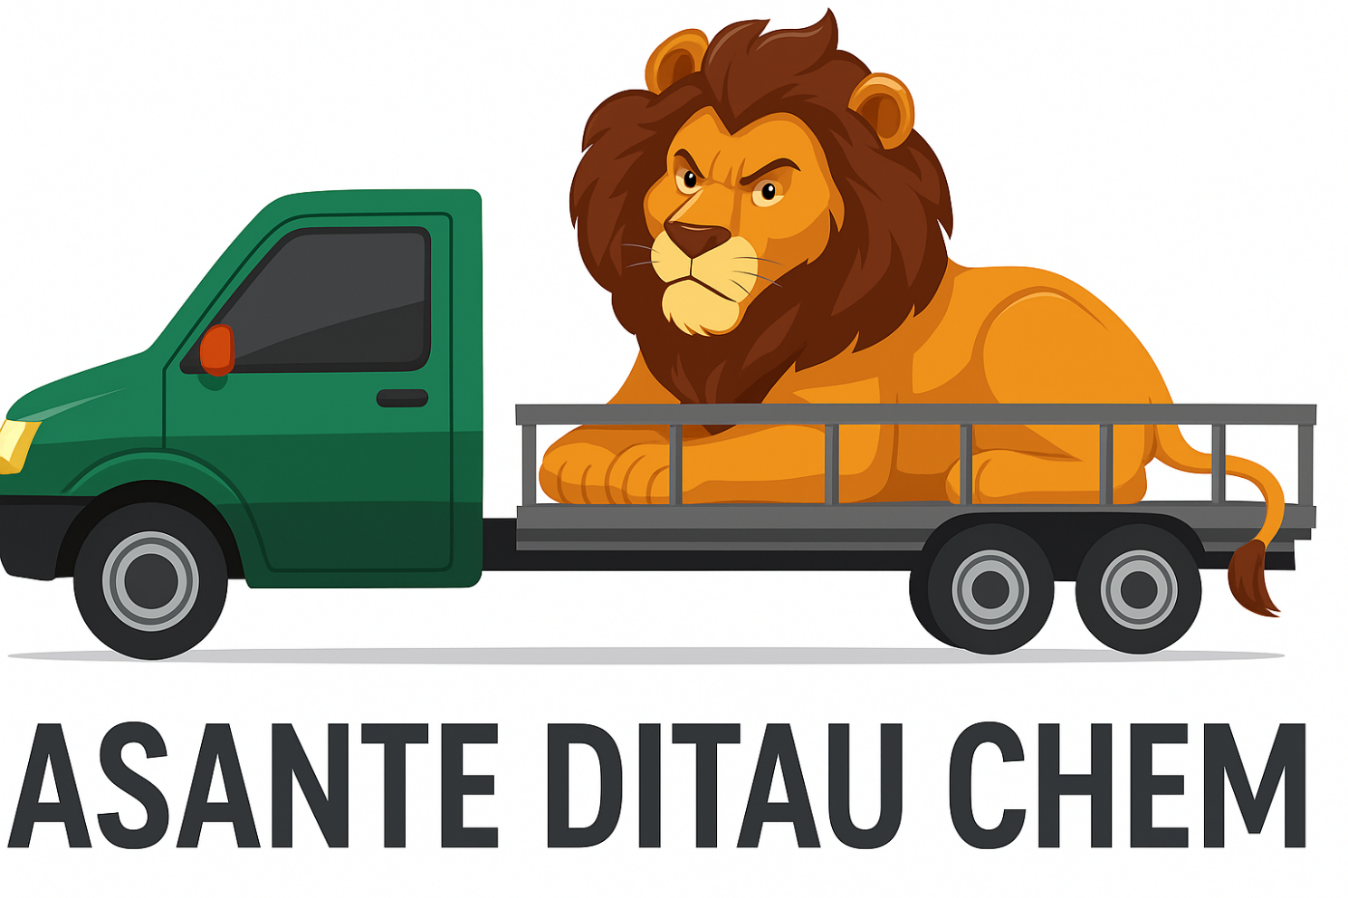

Contents
1. Document Revisions 3
2. Executive Summary 4
3. Company Description 4
4. Products & Services 5
5. Market Analysis 6
6. Marketing & Sales Strategy 7
7. Operations Plan 8
8. Management Structure 10
9. Financial Projections 11
10. Risk Analysis & Mitigation 12

Document Revisions

03/12/2025 | 1.0 | Standard document

Executive Summary

Asante Ditau Chem (Pty) Ltd is a forward-thinking, technology-enabled distributor of cleaning chemicals and materials, strategically positioned to serve South Africa’s rapidly growing cleaning and car wash economy. Headquartered in Gauteng, we specialise in supplying cleaning chemicals, car wash consumables, and hygiene solutions to township car washes, fuel-station car washes, commercial cleaning companies, SMEs, schools, clinics, and light industrial facilities.
What sets Asante Ditau Chem apart is our integration of digital innovation with on-the-ground distribution expertise. Leveraging the founder’s 10 + years of experience in customer service consulting, financial operations, ERP systems, mobile app platforms, and last-mile delivery solutions, we offer a highly efficient, transparent, and reliable supply chain.
We utilise a digital ordering ecosystem (mobile app + WhatsApp API ordering + cloud-based inventory and logistics management) that streamlines procurement for our clients, cuts operational inefficiencies, and ensures fast replenishment.
By sourcing directly from manufacturers—avoiding retail wholesalers—we provide competitive pricing, consistent product availability, and superior technical guidance. Over the next three years, Asante Ditau Chem aims to capture a strong market share by combining quality products, technology, and exceptional service delivery.

Company Description

Business Structure
- Registered Name: Asante Ditau Chem (Pty) Ltd
- Legal Structure: Private Company registered with CIPC
- Industry: Chemical Distribution / Cleaning Supply Chain
Vision
To become South Africa's most trusted and technologically advanced distributor of cleaning and hygiene solutions for car washes, commercial cleaners, and institutional clients.

Mission
To empower cleaning operators and car washes with affordable, high-quality cleaning chemicals delivered through an innovative digital platform, backed by excellent customer service, efficient logistics, and industry expertise.
Core Values
- Reliability – On-time delivery and dependable support
- Innovation – Digital-first operational model
- Quality – Products that meet safety and performance standards
- Empowerment – Supporting SMMEs and township economies
- Ubuntu – Building relationships and partnerships rooted in trust

Products & Services

Primary Product Lines
- Vehicle cleaning chemicals:
  - Car shampoos, snow foams, waxes, polishes, tyre gels
  - Engine cleaners, degreasers, wheel cleaners
- Facility & hygiene chemicals:
  - Multi-purpose cleaners, bleach, disinfectants, sanitizers
- Cleaning consumables:
  - Microfiber cloths, sponges, buckets, gloves, chamois, sprayers
- Packaging:
  - 5L, 20L, 25L bulk chemical containers

Sourcing Strategy
- Direct partnerships with local and international manufacturers
- Procurement from SAHPRA-registered and environmentally compliant suppliers
- Bypassing retail wholesalers (e.g., Makro, West Pack) to maintain price leadership
Service Portfolio
- Digital Ordering Platform
Mobile app for ordering, delivery tracking, re-order reminders, and account management.
- WhatsApp Business Automation
Orders automatically processed into our Platform for fullfilment.
- Just-in-Time Delivery
Same-day/next-day deliveries within Gauteng.
- Technical & Product Support
  - Correct dilution ratios
  - Safety and handling procedures
  - Usage training for car wash staff
- Inventory Management for Clients
Optional stock-level monitoring, recurring orders, and alerts.

Market Analysis

Industry Overview
South Africa’s cleaning chemical market continues to expand due to:
- Increased hygiene awareness
- Growth in informal and semi-formal car wash businesses
- Rising urbanisation and new commercial developments

Although the car wash industry generates millions of rands each year, it is still not adequately supported by specialised distributors.
Target Market Segments
Primary Market
- Township car washes and fuel-station car washes
Secondary Market
- Small and medium cleaning companies
- Domestic cleaning companies
- Complexes and commercial facilities
Tertiary Market
- Schools, clinics, salons, and light industrial operations

Competitive Advantages
- Digital-first distribution model
- Founder’s advanced ERP & logistics experience enabling operational efficiency
- Manufacturer-direct pricing below traditional wholesalers
- Fast delivery turnaround (key problem for car washes)
- Focused expertise in cleaning chemicals vs general wholesalers

Marketing & Sales Strategy

Go-to-Market Strategy
- Deploy sales reps in high-density township areas
- Partner with petroleum station dealers to access on-site car washes
- Build B2B relationships with cleaning service companies and SMEs

Digital Sales & Marketing
- Facebook & Instagram ads targeting local car wash owners
- WhatsApp campaigns showcasing product bundles
- User-friendly mobile ordering app promotion

Promotions
- Starter Pack Deals (Car Wash Essential Kits)
- Loyalty points on recurring purchases
- Bulk-buy discounts for SMEs
- Referral incentives

Sales Channels
- Direct sales team
- Mobile app
- WhatsApp ordering
- Telesales / account managers

Operations Plan

Location
Centralised warehouse in Ekurhuleni for optimal reach.
Supply Chain Operations
- Manufacturer agreements and scheduled replenishment cycles
- Safety-compliant chemical storage facility
- Accurate stock tracking via integrated System

Technology & Systems
Leverages the founder’s experience in:
- ERP systems design & management
- Mobile application platforms for deliveries and merchandising
- Microsoft SQL and data-driven troubleshooting
Key Components:
- Cloud-hosted Inventory platform
- Mobile app with customer ordering and delivery tracking
- WhatsApp API integration for ordering
- Delivery routing optimisation system

Delivery Model
- Phase 1: Light delivery vehicle (leased/owned)
- Phase 2: Expand fleet and/or partner with courier services

Regulatory Compliance
- CIPC Registration
- SARS: VAT, PAYE
- OHSA compliance for chemical storage
- SAHPRA compliance for applicable disinfectants
- POPIA compliance for digital data

Management Structure

Founder & Managing Director: Abel Nkadimeng
Brings a strong background in:
- ERP systems development and management
- Mobile delivery & sales platforms
- Customer service consulting
- Debt collection and financial process control
- Logistics coordination
- Data analysis & reporting through SQL and Excel
This technical and operational expertise gives the business a strong competitive edge in building a cost-efficient, automated distribution model.
Support Team
- Warehouse & Logistics Coordinator
- Sales Representatives
- Customer Success & App Support Agent
- Finance/Admin Officer
Advisory Board (Phase 2)
- Legal and compliance expert
- Logistics consultant

Financial Projections

Startup Costs
- Warehouse setup and deposit
- Initial inventory
- Vehicle lease or purchase
- App & ERP System
- Branding and marketing
- Working capital
Revenue Streams
- Cleaning chemicals
- Consumables
- Bulk order discounts for institutions
- Subscription-based recurring delivery (future)
Projected Turnover
- Year 1: ± R 800,000.00 (break-even by month 10)
- Year 2: ± R 2.5 million
- Year 3: ± R 5 million (expansion to additional province)
Funding Required
Seeking R 600,000.00 in seed funding or business loan for:
- Inventory
- Technology platform
- Vehicle
- Operational runway

Risk Analysis & Mitigation

Regulatory Risks
Mitigation: Early legal consultation, adherence to OHSA and chemical disposal regulations.
Market Risks
Mitigation: Consistent pricing, superior service, strong customer relationships.
Logistics Risks
Mitigation: Fuel surcharge adjustments, route optimisation, backup drivers.

10. Implementation Timeline (6 Months)
Months 1–2
- Finalise all registrations
- Secure warehouse
- Sign supplier agreements
- Build and test digital ordering platform
- Hire initial team
Month 3-4
- Launch in pilot regions: 1 township + 1 industrial area
Months 5–12
- Scale sales
- Hit target of:
  - 50 active car wash clients
  - 20 corporate clients
- Introduce loyalty programme and referral system

--------------------------------------------------------------END------------------------------------------------------------------

